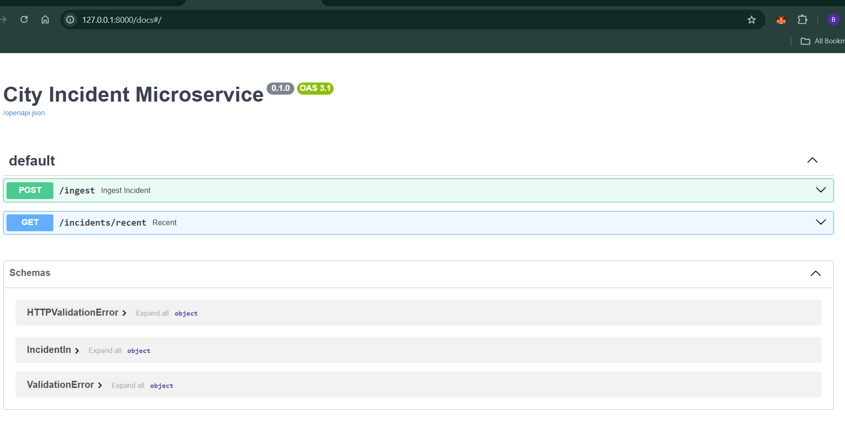

Post

send a POST request with JSON payload to http://127.0.0.1:8000/ingest.
There are 3 simple ways to test it:

✅ Option 1: Using FastAPI Docs (Swagger UI) (Easiest)
- Run your server:
- uvicorn app.main:app --reload --port 8000
- Open browser at:
- http://127.0.0.1:8000/docs
- You’ll see FastAPI’s auto-generated Swagger UI.
- Find the POST /ingest endpoint → click "Try it out".
- Paste this JSON:
- {
- "id": "SR2025-001",
- "type": "Street Light Out",
- "description": "Street light not working near park",
- "reported_at": "2025-10-03T12:00:00",
- "lon": -87.623177,
- "lat": 41.881832,
- "address": "123 W Washington Blvd"
- }
- Click Execute → you should get:
- {"status":"inserted","id":"SR2025-001"}

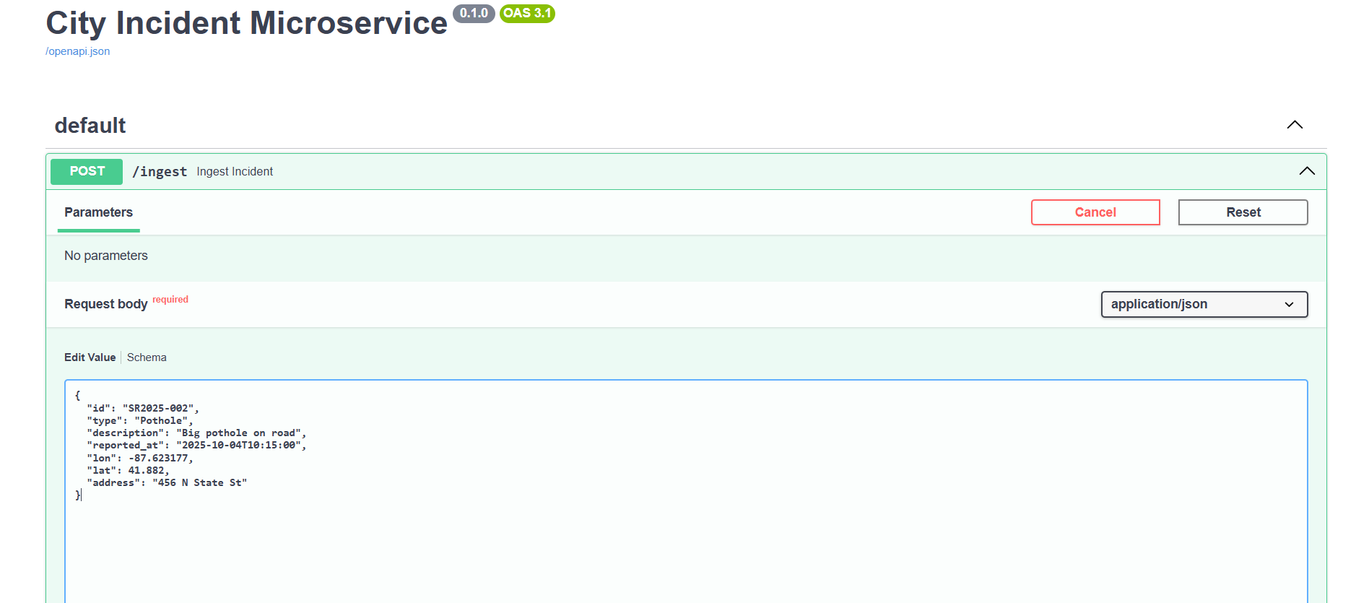
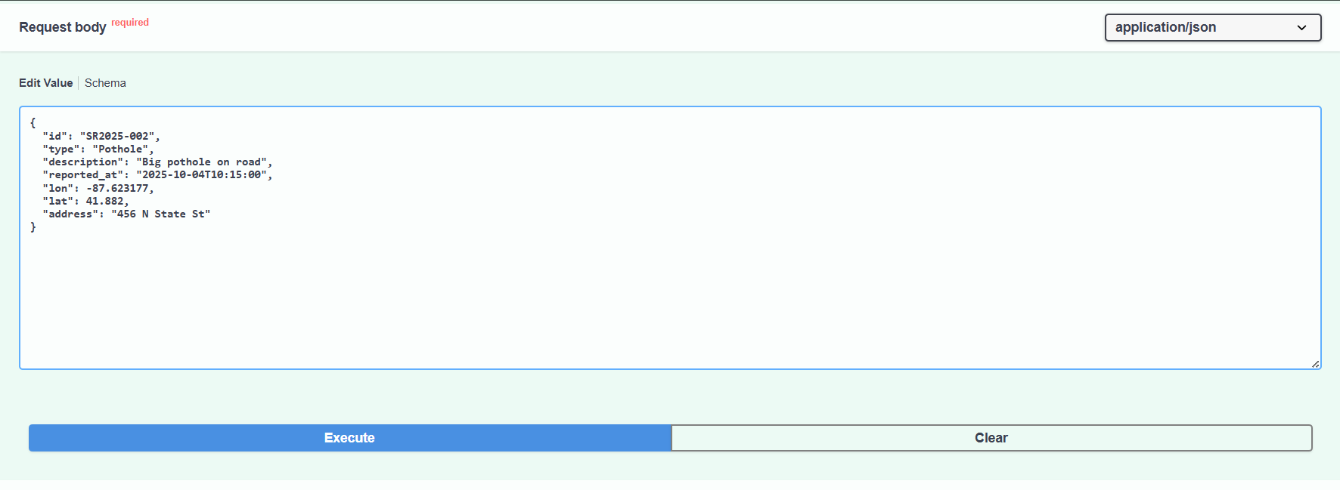
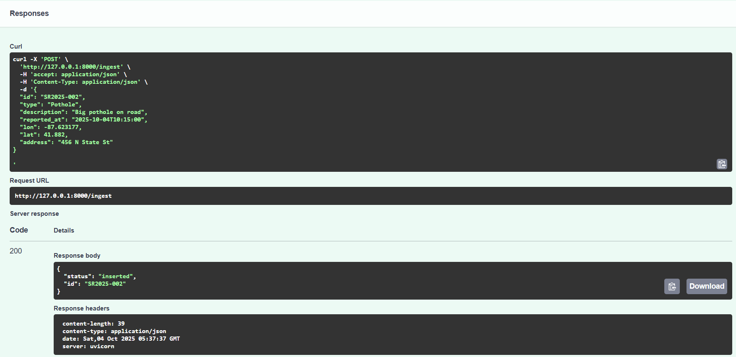
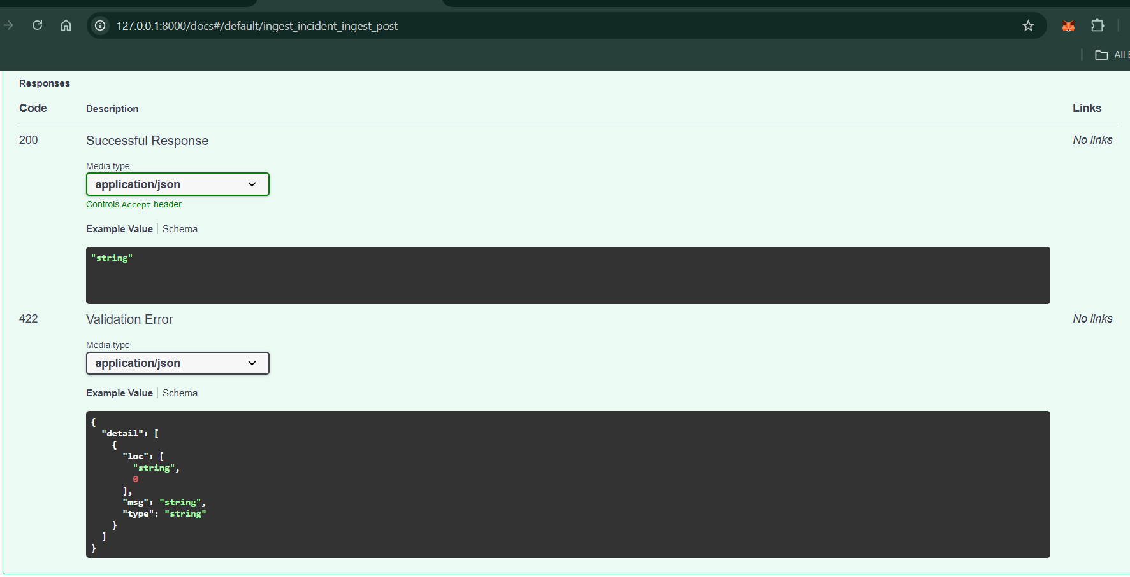

✅ Option 2: Using curl (Command Line)
If you like terminal:
(venv) PS C:\Users\Baseema\OneDrive\Desktop\project\city-incident-ms> Invoke-RestMethod -Uri "http://127.0.0.1:8000/ingest"
-Method POST -Headers @{"Content-Type"="application/json"} -Body '{
>> "id": "SR2025-003",
>> "type": "Street Light Gayi",
>> "description": "Street light band",
>> "reported_at": "2025-10-03T12:00:00",
>> "lon": -87.623177,
>> "lat": 41.881832,
>> "address": "123 W Washington Blvd"
>> }'

status id
------ --
inserted SR2025-003
because curl OR curl.exe doesnot works in windows powershell

✅ Option 3: Using Postman (GUI tool for APIs)
- Open Postman (download free if you don’t have it).
- Create new request: POST → http://127.0.0.1:8000/ingest.
- In Body tab →

{
"id": "SR2025-004",
"type": "Street Light fighting",
"description": "Street light fighting was done by monster",
"reported_at": "2025-10-03T12:00:00",
"lon": -87.623177,
"lat": 41.881832,
"address": "123 W Washington Blvd"
}

- Paste the same JSON as above.
- Click Send → should insert the record.
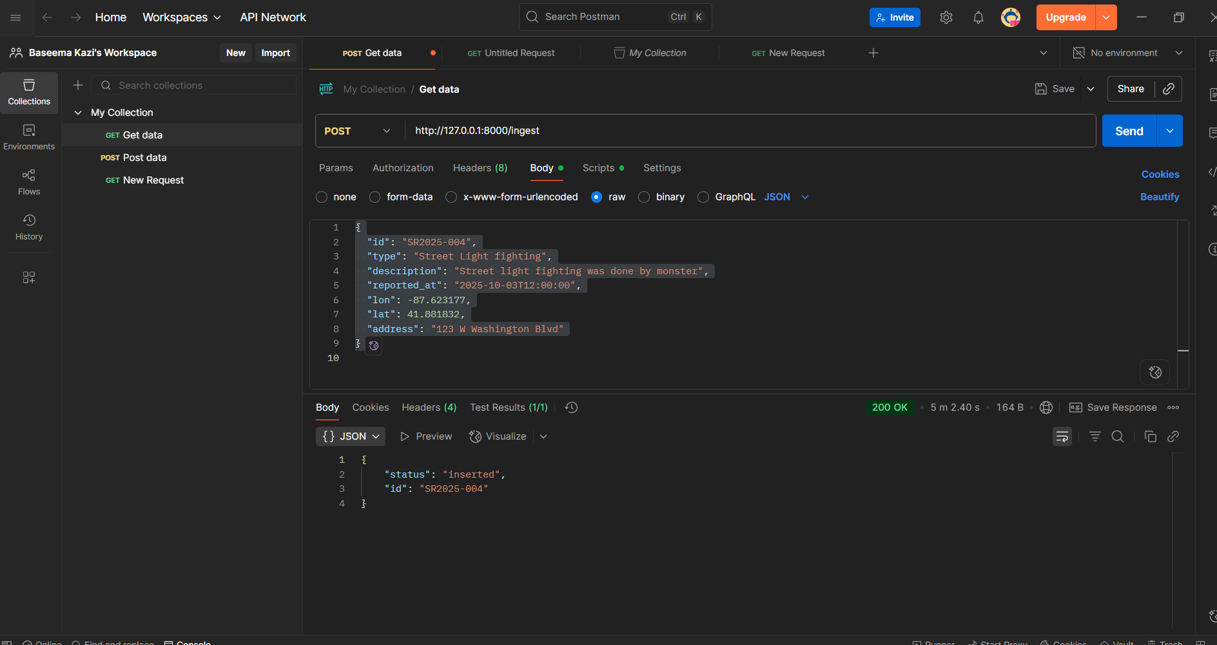

Geospatial Queries

